- Download 2.41 chromedrive :
https://www.nuget.org/packages/Selenium.Chrome.WebDriver/2.41.0

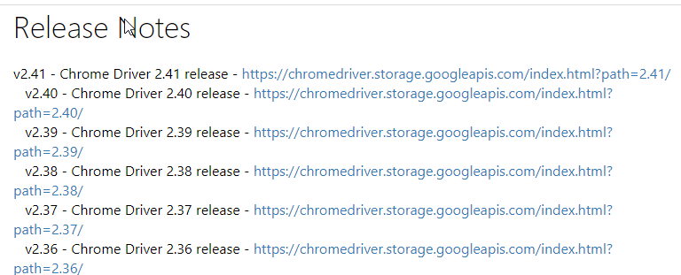

- Select Chrome drive 2.41 : chromedriver_win32.zip
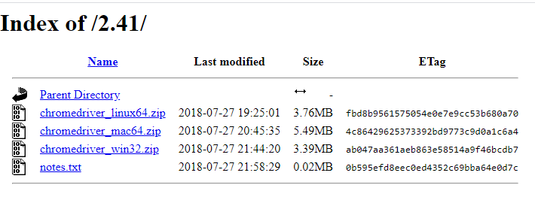

- Info from Assistedge CE, page 314 :
2.38 is the version of the chrome driver. Place the driver inside this folder.
5. Update the configuration file with the browser and driver entries. The file path is given below.

Automation Studio path: \AutomationStudio\ApplicationAutomationMetadata.json
Eg: If we are adding an entry for driver 2.41 then we need to make a ComponentSpecifics json entry under the ComponentName “chrome”. We need to specify following details: -
a. “ThirdPartyVersion”: “2.41”
b. “CompatibleComponentWithThirdParty”: {"MinVersion": "67","MaxVersion": "69"}
c. We also need to add the chrome version supported by added driver in the section SupportedVersions
• "SupportedVersions": ["61","62","63","64","65","66","67","68",”69”]

- I have downloaded chrome driver, replaced it at SeleniumDrivers & remove chrome driver + selevniumdrivers from folder PA; THEN, my health report from Assistedge CE shows as follow :

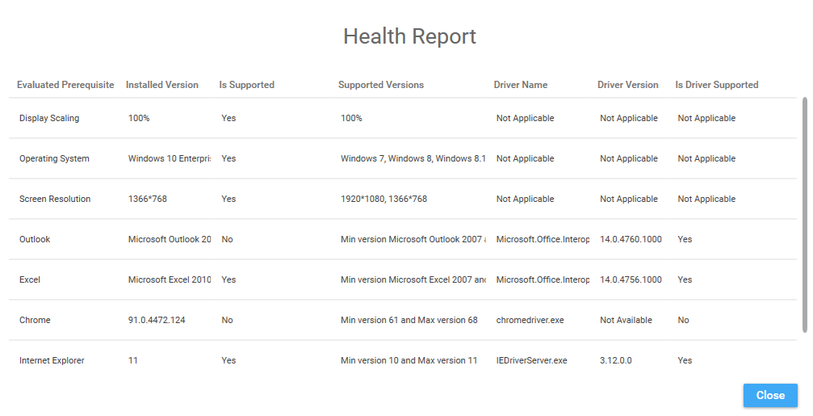
- I am still getting the error about the browser that isn’t compatible.

